**RELAUNCH ANNOUNCEMENT**

**Global Benchmarking Network Relaunch: A New Era of Collaboration and Excellence**

The Global Benchmarking Network (GBN) is excited to announce its highly anticipated relaunch, with details to be shared at two one-hour webinars to accommodate different time zones:

**Session 1:** Wednesday, **30 April 2025**, 10:00 AM UTC

**Session 2:** Wednesday, **21 May 2025**, 6:00 PM UTC

**Register here:** [[**Global Benchmarking Network Relaunch Webinars**](https://www.eventbrite.de/e/global-benchmarking-network-relaunch-webinars-9-april-30-april-2025-tickets-1257110183399?aff=oddtdtcreator)].

This milestone marks a new chapter in GBN’s mission to advance and support benchmarking worldwide.

Since its founding in 1994, GBN has been a cornerstone for organizations dedicated to benchmarking. We are honored to have **Dr. Robert Camp**, the pioneer of modern benchmarking and author of *Benchmarking: The Search for Industry Best Practices That Lead to Superior Performance (1989)*, as our Honorary Lifetime President.

This event signifies the revitalization of GBN, driven by our vision to be recognized as the **global hub for benchmarking**. We invite both organisations and individuals passionate about benchmarking to join our network and play an active role in shaping its future.

**Why This Event Matters**

As the modern business landscape evolves, GBN is stepping boldly into a new era. By embracing digital transformation, sustainability, and global collaboration, we are more committed than ever to driving innovation and excellence worldwide.

The 2025 Relaunch Event offers you the opportunity to:

* **Become a Benchmarking Ambassador** – Join the GBN as an **Organisational Member** to promote benchmarking across organisations, industries, and sectors, or as an **Individual Member** to champion benchmarking within your own organisation and broader networks.
* **Connect with Like-Minded Peers Worldwide** – Join a global network of organisations and individuals working collaboratively to advance benchmarking knowledge.
* **Strengthen Your Benchmarking Capabilities** – Gain access to the latest benchmarking methodologies, tools, and research to support your organisation or personal development.
* **Leverage Benchmarking Tools and Resources** – Benefit from benchmarking publications, databases (including free access to the Best Practice Improvement Resource), and reports to enhance your services.
* **Enhance Recognition** – Elevate your profile nationally and internationally by being part of a respected global benchmarking network.
* **Participate in Prestigious Benchmarking Initiatives** – Engage in GBN’s International Benchmarking Conference, Global Benchmarking Award, International Best Practice Competition (IBPC), and benchmarking projects.
* **Collaborate on Benchmarking Policy and Advocacy** – Play a role in shaping national and international benchmarking frameworks and strategies.
* **Contribute to Benchmarking Capacity Building** – Lead or participate in training programs, workshops, and conferences to support benchmarking excellence.

**Be Part of the Movement**

If you represent an organisation that already provides benchmarking services (or intends to) or you’re an individual passionate about using benchmarking to drive improvement within your own organisation, this is a unique opportunity to expand your impact and collaborate with a global network of like-minded peers.

**New members will not be required to pay a membership fee for at least one year.** Instead, they pledge to promote and support benchmarking in their respective countries, industries, and organisations by advocating for excellence and sharing best practices.

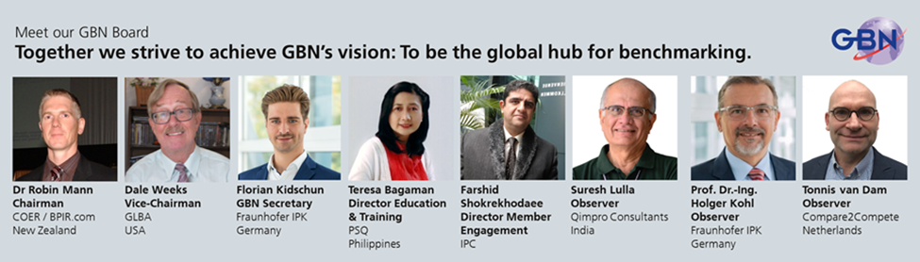

**Join the GBN**

We invite interested organisations and individuals to formally join the GBN.

Access the membership forms here: [[Become a Member](https://www.globalbenchmarking.org/index.php/membership-join/)].

New members will be asked to agree to a set of membership commitments to actively support GBN’s vision.

Our **first meeting with all new members will take place in August 2025**, where we will begin redefining the future of benchmarking — taking your organisation and your country to new heights of excellence.

**Let’s connect, collaborate, and drive excellence together.**  
On behalf of the GBN Board, I look forward to seeing you at one of our webinars and welcoming you to the network!

**Dr. Robin Mann**  
GBN Chairman  
Director, Centre for Organisational Excellence Research  
New Zealand

[www.globalbenchmarking.org](http://www.globalbenchmarking.org)  
[GBN on LinkedIn](https://www.linkedin.com/company/5012282/admin/dashboard/)  
[Find me on LinkedIn](https://www.linkedin.com/in/drrobinmann/)